Linux : why we will use grep command
CI/CD pipeline explaination
about Microservice
what do you know about AWS DevOps, kubernetes architecture
Asked like apart from subversion control system do you know any other version control system.
asked little bit about subversion control system
Remaining my previous project explaination: How to deploy package
what does mean by troubleshooting how you have done that in your previous project
Based on my previous project they have asked more question's (based on my profile).

Below are the interview questions asked by client:
1.Oops concept in java
2.What is Kubernetes(Architecture - Master & work nodes )
3.What is Docker
4.What is a small unit in pod
5.CI/CD pipeline
6.Jenkins workflow
7.Tools that used between docker - K8s (Deployment tool)
8.About my previous project in detail

git init
git remote add origin https://gitlab.spectrumflow.net/vsi-team/integration-automation.git
git clone git@gitlab.spectrumflow.net:vsi-team/integration-automation.git
git branch (should give only main)
git checkout -b feature/cdvrtestdata
git status (should be clean)
git fetch
git pull origin dev
git status (feature branch with tree clean msg)
git branch (show only main and your branch. pointing to your branch)

revert changes:
Git log dev // will give the history of dev branch

//get the commit code which you have to revert, and then give
git revert 710d5f32e28c48e87d994f727c234bd885afad81

HTTP status codes and its definitions
https://developer.mozilla.org/en-US/docs/Web/HTTP/Status

kubectl -n nns-pmirror describe deployment | egrep 'SPRING_PROFILES_ACTIVE|Image'

to check for edit deployment yaml for images pods
kubectl -n nns-pmirror edit deployment nns-ms-account

kubectl -n nns-pmirror describe pod nns-podname

to login into pod
kubectl exec -it -n pmirror nns-event-podname -- bash

to scale up pods
kubectl -n nns-pmirror edit hpa nns-event // --edit min/max replicase under spec

to get po list
kubectl -n nns-pmirror get po

kubectl describe deployments # this gives the image details,time stamp, replicaset info etc

kubernetes: has many clusters in it

Cluster: Combination of multiple servers which shares memory cpu etc. There will be a master and slave nodes in each cluster

Node: A node is a worker machine on Kubernetes. It is a Virtual Machine or a physical machine based on the cluster. A node has many pods

pod: is a group of containers deployed together on the same host. A pod has a many containers which has individual programs running in it.

Programs: are bundled up into a single file called containers and it runs on top of linux package

Why you need Kubernetes
Containers are a good way to bundle and run your applications. In a production environment, you need to manage the containers that run the applications and ensure that there is no downtime. Kubernetes provides you with a framework to run distributed systems resiliently. It takes care of scaling and failover for your application, provides deployment patterns, and more

Docker
Docker builds images automatically by reading the instructions from a Dockerfile which is a text file that contains all commands, in order, needed to build a given image.

# syntax=docker/dockerfile:1

FROM ubuntu:22.04
ARG MAVEN_VERSION=3.5.4
ENV DEST_LOCAL_REPO $USER_HOME_DIR/.m2/repository/
COPY . /app
RUN make /app
CMD python /app/app.py

to trigger build using jenkins pipeline
once the source code management data's populated, Build configuration attribute value to be selected as "By jenkinsfile"
minimal pipeline
pipeline { 1
agent any 2 3
stages { 4
stage('Build') { 5
steps { 6
echo 'This is a minimal pipeline.' 7
}
}
}
}

1. All Declarative Pipelines start with a pipeline section.
2. Select where to run this Pipeline, in this case "any" agent, regardless of label.
3. Declarative automatically performs a checkout of source code on the agent, whereas Scripted Pipeline users must explicitly call checkout scm,
4. A Declarative Pipeline is defined as a series of stages.
5. Run the "Build" stage.
6. Each stage in a Declarative Pipeline runs a series of steps.
7. Run the echo step to print a message in the Console Output

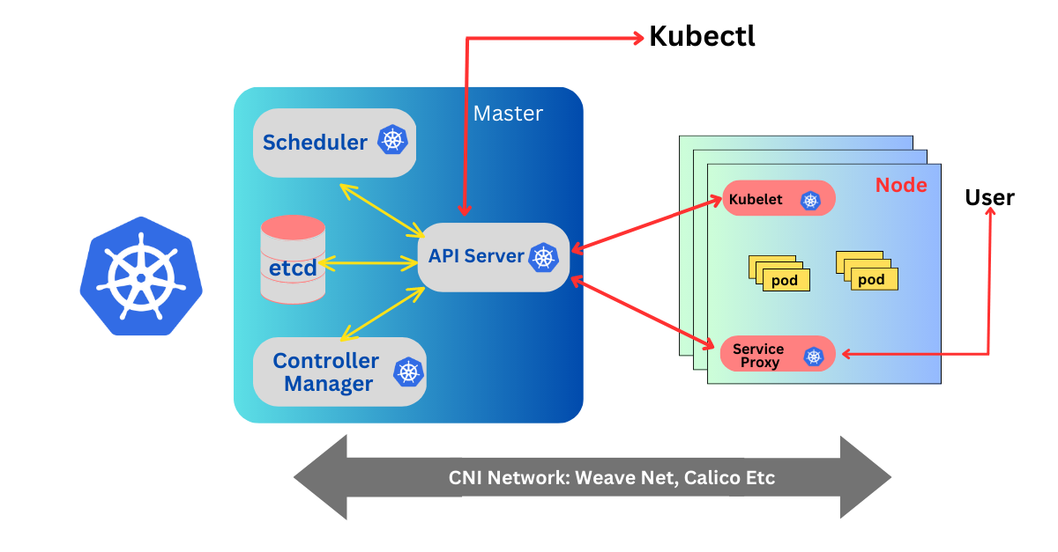

CI/CD pipeline creation with example https://www.geeksforgeeks.org/how-to-make-a-ci-cd-pipeline-in-jenkins/

URL:
https://www.youtube.com/watch?v=scEDHsr3APg

How to Create a CI/CD Pipeline with Harness (Step-by-Step)

INTERVIEW Q:
Linux: why we will use grep command
CI/CD pipeline explanation
about Microservice
what do you know about AWS DevOps, kubernetes architecture
Asked like apart from subversion control system do you know any other version control system.
asked little bit about subversion control system
Remaining my previous project explaination: How to deploy package
what does mean by troubleshooting how you have done that in your previous project
Based on my previous project they have asked more question's (based on my profile).

Below are the questions asked by client:
1. CI / CD pipeline
2. What you know about harness tool
3. Software development cycle
4. Automation tool mentioned in my resume from previous project.
5. Version control system
6. About my previous project in detail

Below are the interview questions asked by client:
1.Oops concept in java
2.What is Kubernetes(Architecture - Master & work nodes )
3.What is Docker
4.What is a small unit in pod
5.CI/CD pipeline
6.Jenkins workflow
7.Tools that used between docker - K8s (Deployment tool)
8.About my previous project in detail

1)Kubernetes
2)Oops in java
3)Previous project details
4)Selenium questions
5)Asked me about the microsoft tools(i mentioned it in my resume)
6)SDLC
7)why devOps?
8)Some questions on cucumber and testng framework (what is feature file)
9)Functional testing vs automation testing

1) Kubernetes architecture
2) OOPs in java
3) STLC
4) Basic Linux commands
5) Difference btw smoke and sanity testing
6) Difference btw integration and end-to-end testing
7) Why did you choose devops
8) manual testing vs automation testing
9) Basic selenium questions - locators
8) About testng framework and different annotations used
9) About project

1)kubernetes
2)linux commands
3)alternative of grep command
4)what is build
5)what you know about API
6) about project
7)Why did you choose devops instead of development
8)what is class , access modifiers, diff dataTypes in java,super keyword.
9)what is framework
10) xpath, types of waits
11)automation vs functional testing
12)about jeera

